Introduction of Anaconda

1. Anaconda Distribution

600백만 명이 넘는 사용자가 Anaconda Distribution을 사용하여 Linux, Windows 및 Mac Os X에서 Phthon 및 R 데이터 과학 그리고 기계 학습을 가장 빠르고 쉬운 방법으로 수행 할 수 있습니다.

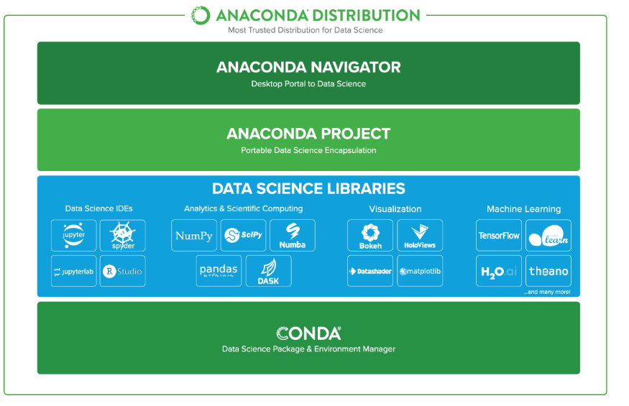

Why Over 6 Million Users Love Anaconda Distribution

* [**Data Science Libraries**](https://www.anaconda.com/distribution/#feature-science-libraries)
* [**Package Management**](https://www.anaconda.com/distribution/#feature-package-management)
* [**Desktop GUI**](https://www.anaconda.com/distribution/#feature-desktop-gui)

|  |
| --- |
|  |
| Anaconda Data Science Libraries   * - Over 1,400 Anaconda-curated and community data science packages * - Develop data science projects using your favorite IDEs, including Jupyter, JupyterLab, Spyder, and RStudio * - Analyze data with scalability and performance with Dask, numpy, pandas, and Numba * - Visualize your data with Matplotlib, Bokeh, Datashader, and Holoviews * - Create machine learning and deep learning models with Scikit-learn, Tensorflow, h20, and Theano |
|  |
| Conda, the Data Science Package & Environment Manager   * - Automatically manages all packages, including cross-language dependencies * - Works across all platforms: Linux, macOS, Windows * - Create virtual environments * - Download conda packages from Anaconda, Anaconda Enterprise, Conda Forge, and Anaconda Cloud |
|  |
| Anaconda Navigator, the Desktop Portal to Data Science   * - Install and launch applications and editors including Jupyter, RStudio, Visual Studio Code, and Spyder * - Manage your local environments and data science projects from a graphical interface * - Connect to Anaconda Cloud or Anaconda Enterprise * - Access the latest learning and community resources |

1. Anaconda Enterprise

Anaconda Enterprise는 AI/ML 지원 플랫폼으로 교육을 통해 노트북에서 AI/ML 및 데이터 과학 개발, 관리 및 자동화 할 수 있도록 지원합니다.

